

**CATLY PREMIERES FIRST LOOK TRAILER AT THE GAME AWARDS FEATURING STUNNING AAA CATS**

*Interactive open-world adventure will come to Steam, Nintendo SwitchTM, and Apple Watch next year*

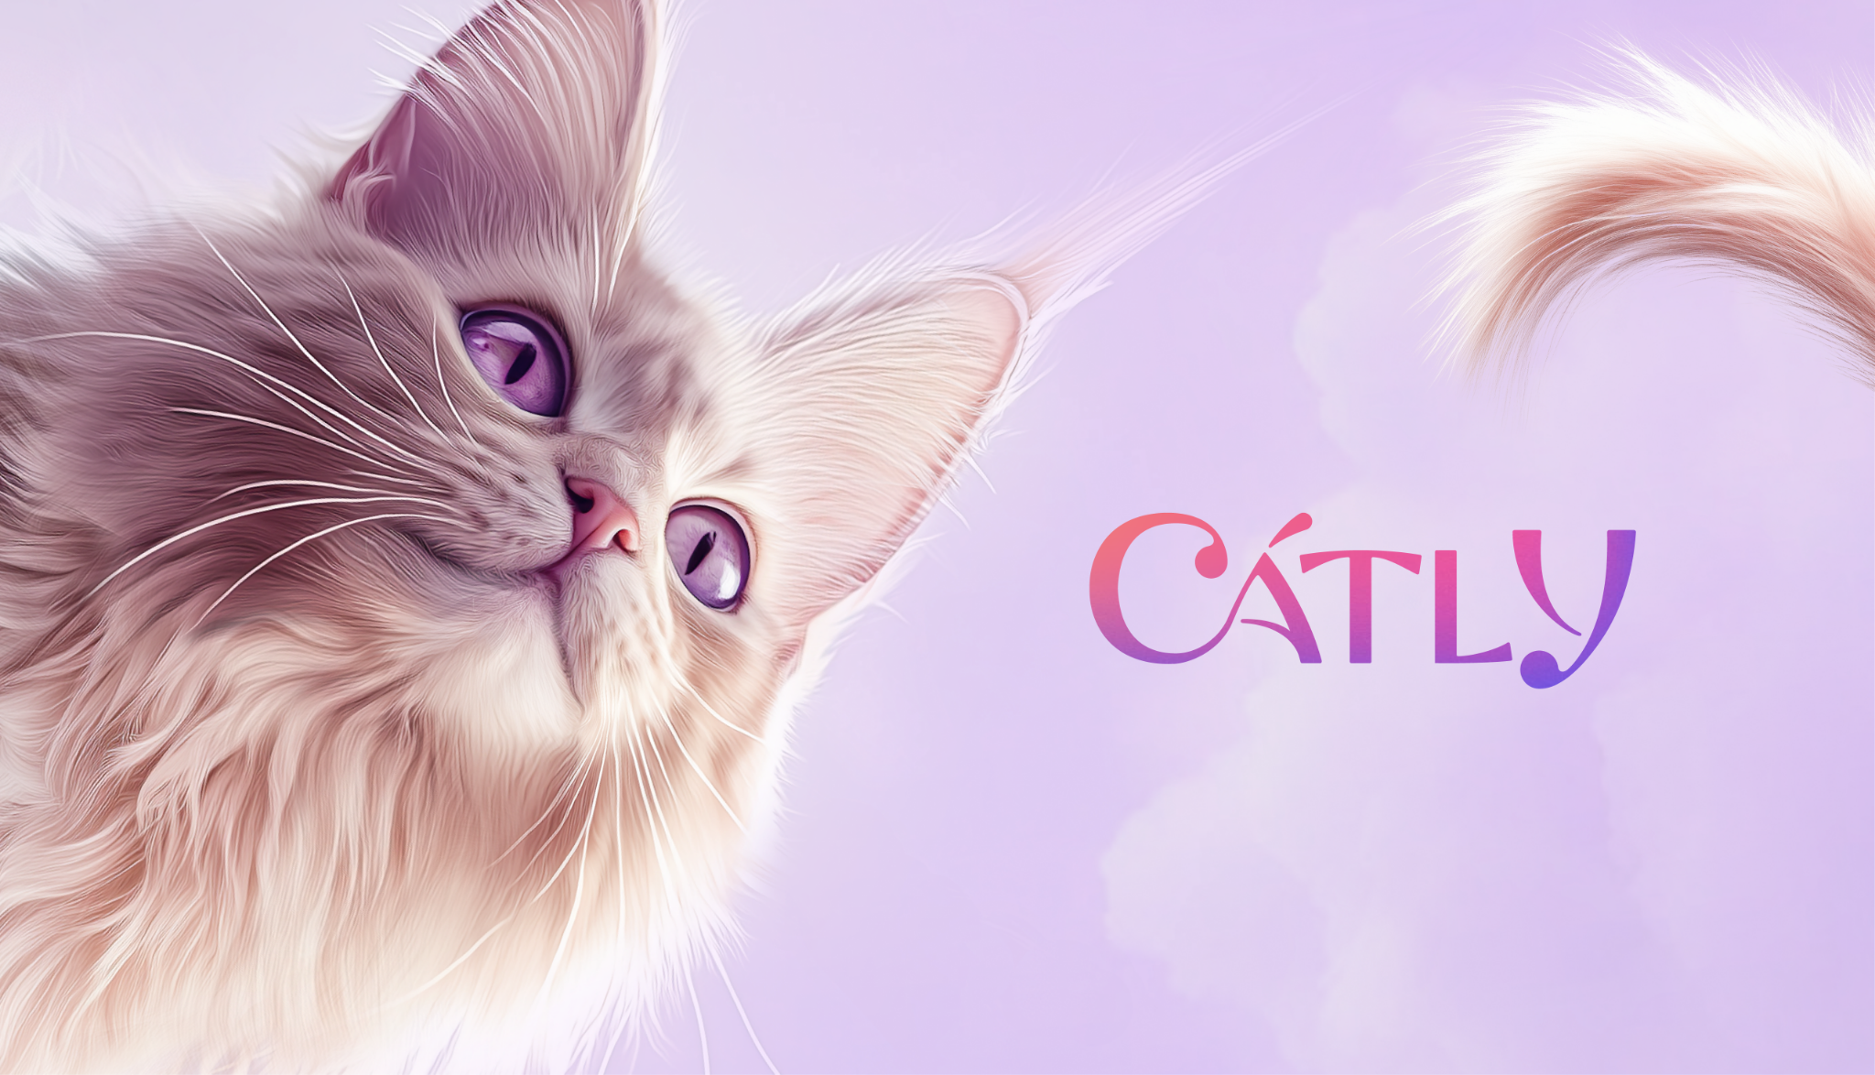

LOS ANGELES - Dec. 12, 2024 – Hyper-realistic cats have the game world abuzz as Catly premiered the global debut trailer for the stunning, imaginative, technologically innovative open-world cat game during this year’s annual The Game Awards celebration. The trailer is the first-ever sneak peek into the interactive and charming mannerisms of the game industry’s most ambitious animals to date.

[TRAILER](https://drive.google.com/file/d/1Y_P2-PwJSNZ82XA-64apzwct0Tlefmcs/view)

Catly is an interactive adventure starring beautiful and hyper-realistic cats coming to Steam, Nintendo Switch, and Apple Watch - because everyone deserves a cat anywhere, anytime. The game is a love letter to cats, made for cat lovers by cat lovers. Every encounter celebrates cat mannerisms that showcase cats’ playfulness, grace, coziness, and of course, mischief.

Catly is about authentic companionship and empowering cats to accomplish feats that cat lovers normally can only dream of. Solo and multiplayer adventures and quests are full of thrilling exploration and world-crafting with endearing, stylish cat companions.

Every cat in Catly is unique, and players will choose and craft endless possibilities with accessories and environments to individualize each feline friend. Players will be able to create stylish one-of-a-kind cats to match their personalities.

Catly currently is available to [wishlist on Steam](https://apps.apple.com/us/app/catly-your-wrist-buddy/id6737467506) and [pre-order on Apple Watch](https://apps.apple.com/us/app/catly-your-wrist-buddy/id6737467506). Follow [Catly on X](https://x.com/PlayCatly) and register on the [Catly website](http://playcatly.com) to be the first to see updates and further announcements.

More on Catly will be revealed in 2025.

# # #

Images and assets are available in the Catly [press kit](https://zebrapartners.com/catly-press-kit/).

Media contact:

Johner Riehl

Zebra Partners for Catly

[catlymedia@zebrapartners.net](mailto:catlymedia@zebrapartners.net)