Games for Change Announces 2026 Award Winners

South of Midnight named Game of the Year; Consume Me takes three awards
at the annual G4C Awards Ceremony
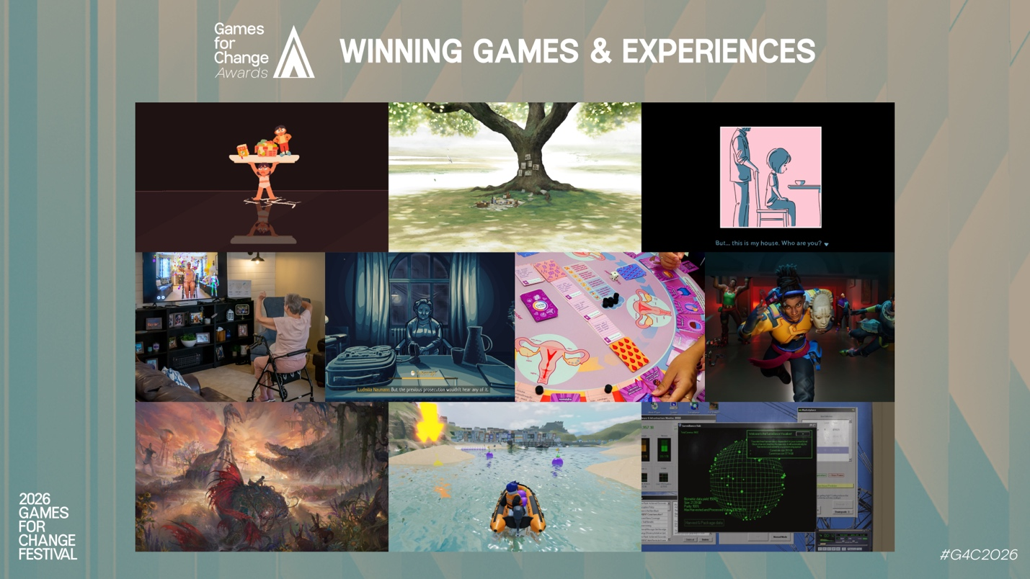

NEW YORK, July 21, 2026 - Today, Games for Change (G4C), the nonprofit organization dedicated to harnessing games and immersive media for social impact, announced the winners for the 2026 Games for Change Awards. Chosen from a field of submissions spanning 42 countries, the winners were revealed live at the G4C Awards Ceremony, held during the annual Games for Change Festival in New York and hosted by actors Anjali Bhimani (Overwatch, Apex Legends, Ms. Marvel) and Osric Chau (Supernatural, Dirk Gently's Holistic Detective Agency).
“It has been a remarkable year for games made with purpose, and these winners show the breadth of it,” said Games for Change President Susanna Pollack. “They come from studios and institutions across five continents, each one turning to a game or interactive experience to say something that mattered to them. That is what we’re celebrating– how global this work has become.”

The 2026 Games for Change Winners Are:
GAME / EXPERIENCE OF THE YEAR
South of Midnight (Compulsion Games) - An action-adventure set in the American Deep South, where a young woman learns to weave an ancient power as she confronts folkloric creatures and uncovers her family's hidden past.
BEST NARRATIVE, BEST GAMEPLAY, INDIE BREAKOUT AWARD
Consume Me (Hexecutable) - A semi-autobiographical life-sim RPG where every small choice about eating, studying, and fitting in feeds an all-consuming drive to become "better."
BEST IN IMPACT
and Roger (TearyHand Studio) - A touching, interactive novel about seeing the world through someone else's reality.
BEST IN LEARNING
The Darkest Files (Paintbucket Games) - An investigation and courtroom game set in 1956 Germany, where the player works as a prosecutor building cases against former Nazis who escaped justice.
BEST IN COMMUNITY EMPOWERMENT
Relooted (Nyamakop) - An African futurist heist game where players plan and pull off missions to reclaim real looted African artifacts from Western museums and private collections.
BEST IN ENVIRONMENTAL IMPACT
FACEMINER (Wristwork) - A narrative-driven management sim set in 1999 that casts the player as the operator of a biometric data empire, tracing the environmental cost of data and computing.
BEST IN HEALTH & WELLNESS
ARWell PRO (Augment Therapy) - An augmented reality exergaming platform that turns a person's body into the controller, letting clinicians build and remotely monitor therapeutic movement programs across clinic and home settings.
BEST IN XR & EMERGING MEDIA
A Long Goodbye (Timescapes & Polygoat) - An animated, interactive VR experience that places the participant in the life of Ida, a 72-year-old pianist living with dementia, across a single fading day.
BEST PLATFORM-BASED PROJECT
Planet Planners on Roblox (Playerthree & BBC Bitesize) - A curriculum-linked geography game where students travel to real-world environments and make decisions about challenges such as natural disasters, coastal erosion, and city management.
BEST BOARD OR TABLETOP GAME FOR IMPACT
Ciclo do Poder / Cycle of Power (Fiocruz) - A cooperative tabletop game for up to ten players that helps a character named Cris navigate her first menstrual cycle and opens conversations about menstrual health in schools.
2026 Games for Change Special Awards
The G4C Awards also recognized special award honorees for their broader contributions to games and social impact.
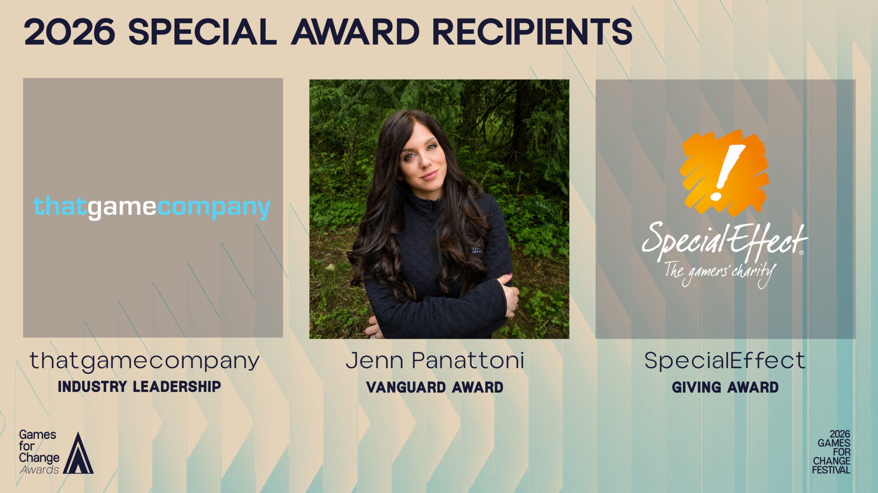
VANGUARD AWARD
Jenn Panattoni - A pioneer of social impact work inside the games industry, Panattoni founded the Xbox Social Impact team in 2018 and built campaigns that generated more than $250 million in value for nonprofits worldwide. She now leads Aizle Impact, an agency building cause partnerships across gaming and entertainment.
INDUSTRY LEADERSHIP AWARD
thatgamecompany - For two decades, thatgamecompany has reimagined what games can be, with titles including Flower, Journey, and Sky: Children of the Light that put emotion and human connection at their core. Led by co-founder and game director Jenova Chen, the studio's Sky: Children of the Light has passed 300 million downloads since its 2019 launch.
GIVING AWARD
SpecialEffect - Since 2007, the UK charity SpecialEffect has helped people with physical disabilities play video games through individually tailored assistive technology, including eye-control and adapted controllers. Its occupational therapists and gaming specialists build bespoke setups for hundreds of players each year and share what they learn as free, open resources.
ACCESSIBILITY AWARD
EA Sports FC 26 (EA Sports) - One of the first sports titles to include a High Contrast Mode usable in competitive play, alongside text-to-speech, colorblind filters, customizable subtitles, and gameplay assists that widen access for players with a range of disabilities.
###

About Games for Change
Since 2004, Games for Change (G4C) has empowered game creators and innovators to drive real-world change, using games and immersive media that help people learn, improve their communities, and contribute to making the world a better place. G4C partners with technology and gaming companies, nonprofits, foundations, and government agencies to run world-class events, public arcades, design challenges, and youth programs. G4C supports a global community of game developers using games to tackle real-world challenges, from humanitarian conflicts to climate change and education.

For more information, contact:
g4c_team@zebrapartners.net

Games for Change Press Kit:
Press Kit

